



ML Ops & Containerization
LAB MANUAL

Disclaimer: The content is curated from online/offline resources and used for educational purpose only
Employee Attrition Prediction API Development Using FastAPI
Objective
To develop a REST API using FastAPI that predicts whether an employee is likely to leave an organization based on employee-related information.
Problem Statement
A company's Human Resources (HR) department wants to identify employees who are likely to leave the organization. Develop a machine learning REST API using FastAPI that accepts employee details and predicts whether an employee is likely to stay or leave.
Requirements
- Python 3.x
- FastAPI
- Uvicorn
- Scikit-learn
- Pandas
- NumPy
- Joblib
- VS Code
- Employee Attrition Dataset.xlsx – Uploaded in the dataset folder
- Web Browser
Procedure
Create a new project folder with the following structure:
employee-attrition-api/
│
├── app.py
├── train_model.py
├── employee_attrition.xlsx
├── attrition_model.joblib (created after training)
└── requirements.txt
Open the folder in Visual Studio Code.
Step 2: Install Required Python Libraries
Open the terminal in VS Code and install the required packages:
pip install fastapi uvicorn pandas numpy scikit-learn joblib

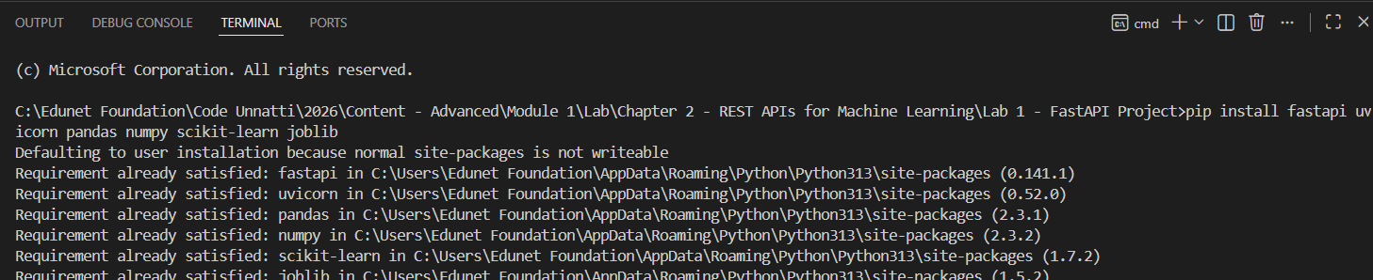
Verify the installation:
pip list

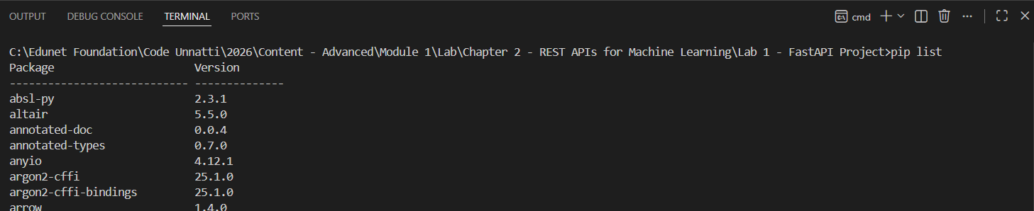
Step 3: Examine the Dataset
The provided dataset, employee_attrition.xlsx, contains 500 employee records with 28 columns, including numeric attributes (Age, MonthlyIncome, TotalWorkingYears, JobSatisfaction, and others) and categorical attributes (Department, BusinessTravel, EducationField, Gender, JobRole, MaritalStatus, OverTime). The target column is Attrition, with values "Yes" or "No".
Step 4: Train the Employee Attrition Prediction Model
Create a file named train_model.py with the following code:
import pandas as pd
from sklearn.model_selection import train_test_split
from sklearn.compose import ColumnTransformer
from sklearn.pipeline import Pipeline
from sklearn.preprocessing import OneHotEncoder
from sklearn.ensemble import RandomForestClassifier
import joblib

# 1. Load the dataset
data = pd.read_excel("employee_attrition.xlsx")

# 2. Separate features (X) and target (y)
# Use every column except the target instead of a hand-picked subset, so the model can learn from all available signals.
X = data.drop(columns=["Attrition"])

# The target is text ("Yes"/"No"); map it to 1/0 so it is unambiguous and consistent with the API's prediction output.
y = data["Attrition"].map({"Yes": 1, "No": 0})

# 3. Identify categorical vs. numerical columns
categorical_cols = X.select_dtypes(include=["object"]).columns.tolist()
numerical_cols = X.select_dtypes(exclude=["object"]).columns.tolist()

# 4. Build a preprocessing step
# Numeric columns pass through unchanged. Categorical columns (e.g. OverTime, Department, JobRole) are one-hot encoded so the model receives only numeric input, as scikit-learn requires. handle_unknown="ignore" prevents the API from crashing later if it ever sees a category value not present during training.
preprocessor = ColumnTransformer(transformers=[
("num", "passthrough", numerical_cols),
("cat", OneHotEncoder(handle_unknown="ignore"), categorical_cols),
])

# 5. Combine preprocessing and model into a single pipeline
# Bundling both steps means the exact same preprocessing is always applied at prediction time - nothing has to be re-implemented inside app.py.
model = Pipeline(steps=[
("preprocessor", preprocessor),
("classifier", RandomForestClassifier(n_estimators=200, random_state=42)),
])

# 6. Split into training and test sets
# stratify=y keeps the Yes/No ratio consistent between the training and test sets, which matters because attrition datasets are usually imbalanced.
X_train, X_test, y_train, y_test = train_test_split(
X, y, test_size=0.2, random_state=42, stratify=y
)

# 7. Train the model
model.fit(X_train, y_train)

# 8. Evaluate on the held-out test set
accuracy = model.score(X_test, y_test)
print(f"Model Training Completed. Test Accuracy: {accuracy:.2f}")

Run the script from the terminal:
python train_model.py

Step 5: Save the Trained Model Using Joblib
Add the following lines to the end of train_model.py, after the accuracy is printed:
# 9. Persist the trained pipeline to disk
# Saving the full Pipeline (not just the classifier) ensures the one-hot encoding logic is saved alongside the model, so app.py does not need to duplicate any preprocessing code.
joblib.dump(model, "attrition_model.joblib")
print("Model Saved Successfully")

Run the script again:
python train_model.py

A file named attrition_model.joblib will now be created in the project folder.
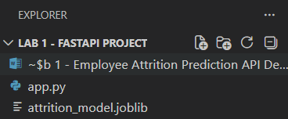

Step 6: Create the FastAPI Application (app.py)
Create a file named app.py with the following code:
from fastapi import FastAPI
from pydantic import BaseModel
import pandas as pd
import joblib

app = FastAPI(title="Employee Attrition Prediction API")

# Load the trained pipeline once, when the API starts.
# Loading it inside the endpoint function would reload the model from disk on every single request, which is slow and unnecessary.
model = joblib.load("attrition_model.joblib")

@app.get("/")
def home():
"""Simple health-check endpoint."""
return {"message": "Employee Attrition Prediction API"}

Step 7: Define the Request Schema and Prediction Endpoint
The model was trained on all 27 feature columns in the dataset, several of which are categorical text fields (e.g. Department, OverTime). A Pydantic model is used to validate the incoming request body and to ensure every required field is supplied with the correct data type before a prediction is attempted. Add the code below in app.py file
class EmployeeInput(BaseModel):
Age: int
BusinessTravel: str
Department: str
DistanceFromHome: int
Education: int
EducationField: str
EnvironmentSatisfaction: int
Gender: str
JobInvolvement: int
JobLevel: int
JobRole: str
JobSatisfaction: int
MaritalStatus: str
MonthlyIncome: int
NumCompaniesWorked: int
OverTime: str
PercentSalaryHike: int
PerformanceRating: int
RelationshipSatisfaction: int
StockOptionLevel: int
TotalWorkingYears: int
TrainingTimesLastYear: int
WorkLifeBalance: int
YearsAtCompany: int
YearsInCurrentRole: int
YearsSinceLastPromotion: int
YearsWithCurrManager: int

@app.post("/predict")
def predict(employee: EmployeeInput):
# Convert the validated request body into a single-row
# DataFrame. Column names must match those used during training, since the saved pipeline looks them up by name.
row = pd.DataFrame([employee.dict()])

# The pipeline applies the same one-hot encoding used in training automatically, so raw text fields like OverTime or Department can be passed in directly.
prediction = model.predict(row)[0]
probability = model.predict_proba(row)[0][1]

result = "Employee Likely to Leave" if prediction == 1 else "Employee Likely to Stay"

return {
"prediction": result,
"attrition_probability": round(float(probability), 2),
}

Step 8: Run the FastAPI Application Using Uvicorn
Execute the following command in the terminal:
uvicorn app:app --reload

Click on http://127.0.0.1:8000 and check the expected output:
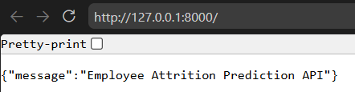

Step 9: Test the API Using Sample Employee Details
Open the interactive API documentation:
http://127.0.0.1:8000/docs

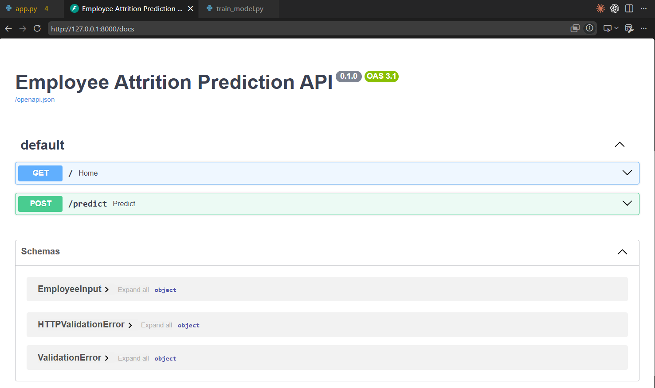
Click POST /predict, then Try it out, and replace the sample request body with the following values:
{
"Age": 34,
"BusinessTravel": "Travel_Rarely",
"Department": "Research & Development",
"DistanceFromHome": 8,
"Education": 3,
"EducationField": "Life Sciences",
"EnvironmentSatisfaction": 3,
"Gender": "Female",
"JobInvolvement": 3,
"JobLevel": 2,
"JobRole": "Laboratory Technician",
"JobSatisfaction": 4,
"MaritalStatus": "Married",
"MonthlyIncome": 55000,
"NumCompaniesWorked": 2,
"OverTime": "Yes",
"PercentSalaryHike": 14,
"PerformanceRating": 3,
"RelationshipSatisfaction": 3,
"StockOptionLevel": 1,
"TotalWorkingYears": 5,
"TrainingTimesLastYear": 2,
"WorkLifeBalance": 3,
"YearsAtCompany": 4,
"YearsInCurrentRole": 3,
"YearsSinceLastPromotion": 1,
"YearsWithCurrManager": 2
}

Click Execute.
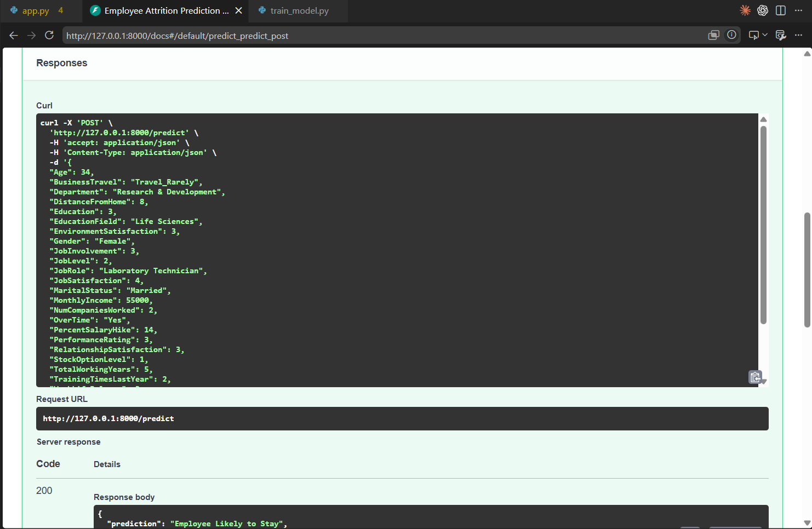
Step 10: Verify the Prediction Results
The API returns a JSON response similar to the following:
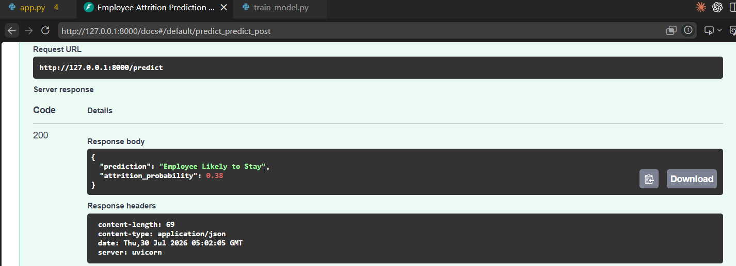

Conclusion
In this lab, a complete end-to-end machine learning REST API was built and deployed locally using FastAPI. A RandomForestClassifier was trained on the employee_attrition.xlsx dataset inside a scikit-learn Pipeline that combines preprocessing (one-hot encoding of categorical fields) with the classifier, ensuring the exact transformations used during training are automatically reapplied at prediction time. The trained pipeline was persisted with joblib and loaded once at application startup for efficient repeated inference. A POST /predict endpoint, backed by a Pydantic schema, validates incoming employee records and returns both a predicted attrition outcome and a probability score, while a GET / endpoint provides a simple health check.

